2019 Collingswood Holiday Ornament

COLLINGSOOD BOOK FESTIVAL
24TH in a series - this is a limited edition of 250
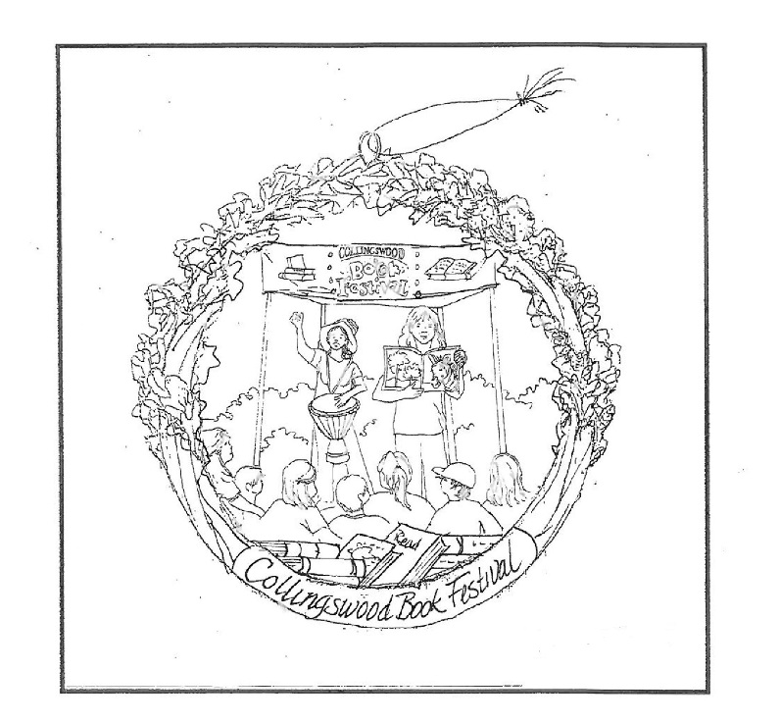

Please complete the form below, make check payable to Collingswood Partners, Inc.
and mail to PO Box 9000, Collingswood, NJ 08108. Mail today to reserve!
All orders are processed first come-first serve.
Ornaments will be available for pick up at DIG THIS, 717 Haddon Avenue.
You will be contacted when ornaments are available for pick up.

Name __________________________________________________________________

Address __________________________________________________________________

Phone __________________________________________________________________

Email __________________________________________________________________

Ornament __________ x $25 = $___________

Stand __________ x $ 4 = $___________

Delivery Options: STORE PICK UP (FREE)
(Select One) SHIP TO HOME ($10) = $___________

TOTAL $___________

2019

